**Citibank Corporate Card Payment**

**(using Citibank Savings Account)**

**Step 1:** Login to your Citibank Salary/Savings Account.

**Step 2:** Select “Transfer to Citibank Account” under Payee List.

**Step 3:** Click on “Add New Payee” under “Transfer to Other Citibank Account”.

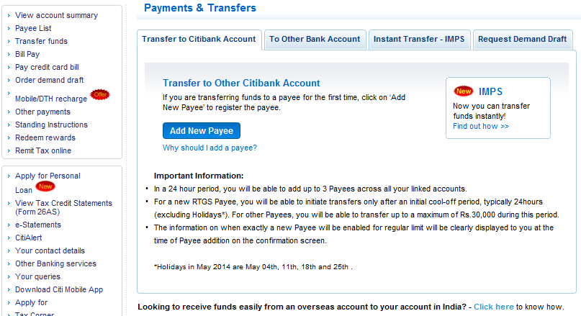

S**tep 4:** Enter the details like, Account Number, City & Nickname and submit.

**(Account Number – 16 digits Corporate Credit Card Number, City – MUMBAI, Nickname – as per your choice)**

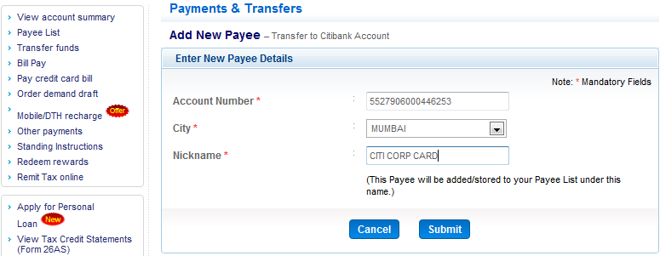

**Step 5:** Verify the details in the “Pre-Confirmation – New Payee” screen, and Confirm. **Ensure the Name is displayed as “COMM CARD COLLECTION A/C”**.

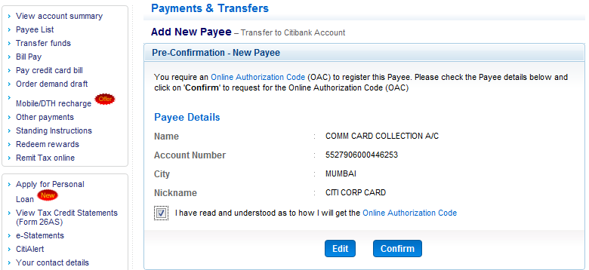

**Step 6:** Authorize payee by clicking on “Authorize Payee Now” and entering the 6 digit authorization code received through SMS on your registered mobile number.

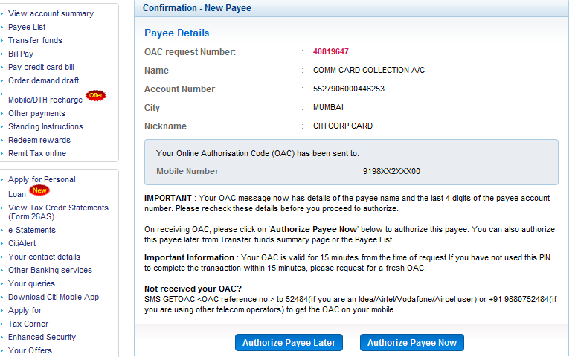

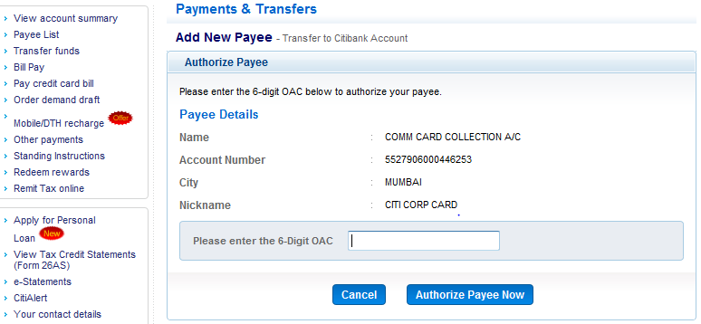

**Step 7:** Make payment by selecting “Make Payment Now” option.

